Click if you COMPLETED the task

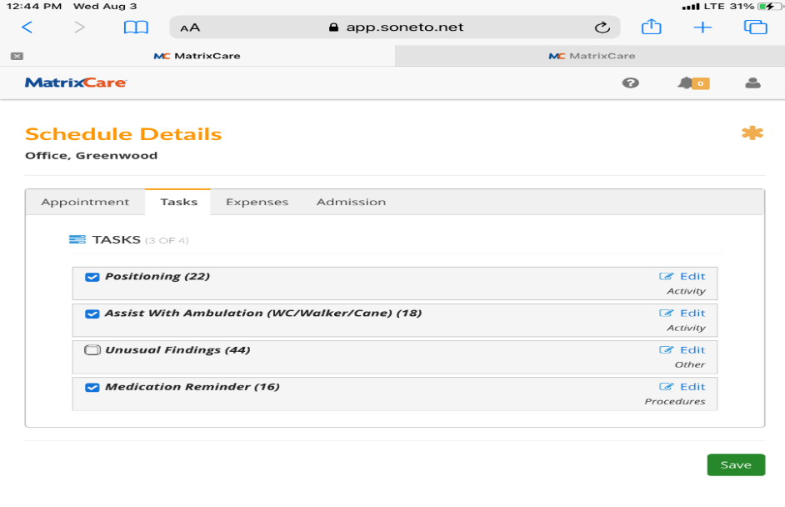
IF Task NOT COMPLETED, do not check the box. Click this icon instead

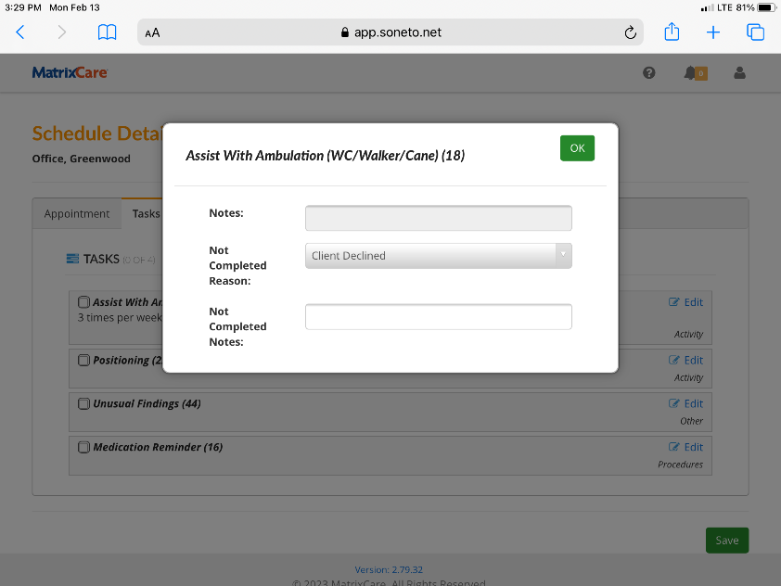
A box will pop up depending on if there are frequencies setup. If this box appears:
Select an option from the dropdown (required to clock out)
Put a note in for why not complete

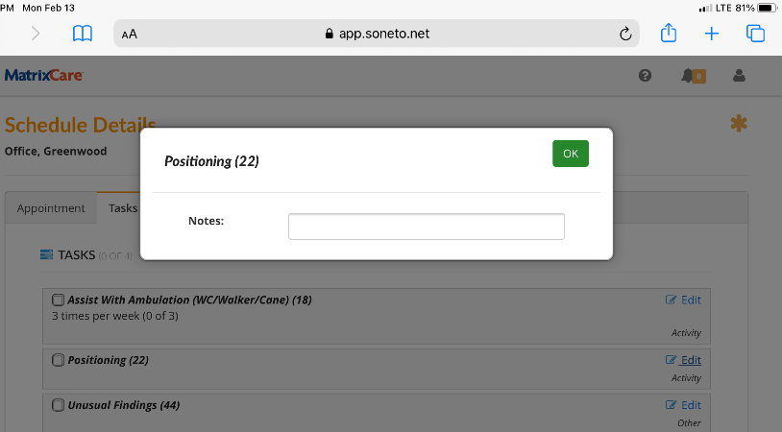
If frequency not indicated, this box will appear after clicking the box with the pencil icon as indicated above. Put in a note for why the task was not done

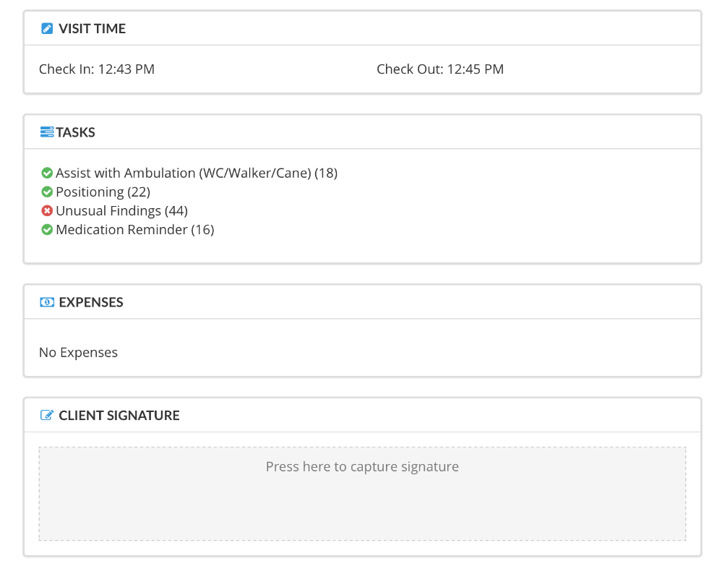
Your screen will have a checkmark on those that were completed and an “x” for those not completed. Click on client signature box and have your client sign.

